**Project: - Physician Compare Dataset**

**Name: - Bhavana Vankhede UB ID: - 1034353**

**MAP REDUCE PROGRAMMING: -**

1. Storing data in Map Reduce using Key, Value pair.

As per requirement, I have used professional id which is PAC_ID from dataset and Enrollment ID which is Professional Enrollment ID from source dataset, to get detaials about professionals enrolled with multiple offices.

Key PAC_ID (Physician's ID) and Value (enrollment ID)

In order to run map reduce program, shell wrapper script is created I.e. map_Reduce.sh script.

**Command**: -

Sh -x map_reduce.sh

Above script uses below commands to run map reduce program: -

hadoop jar PhysComp.jar solution.PhysComp /user/training/PhysComp/sample_out.csv /user/training/OUTPUT11

**Execution Details: -**

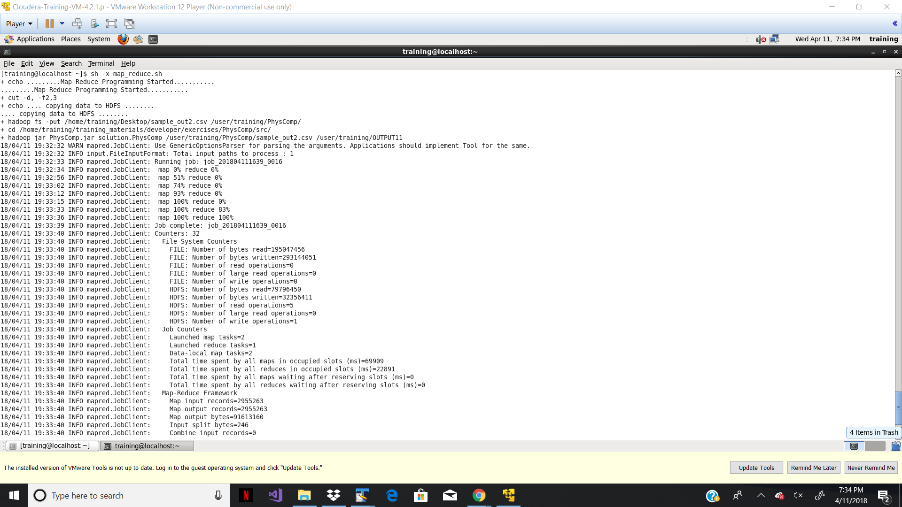

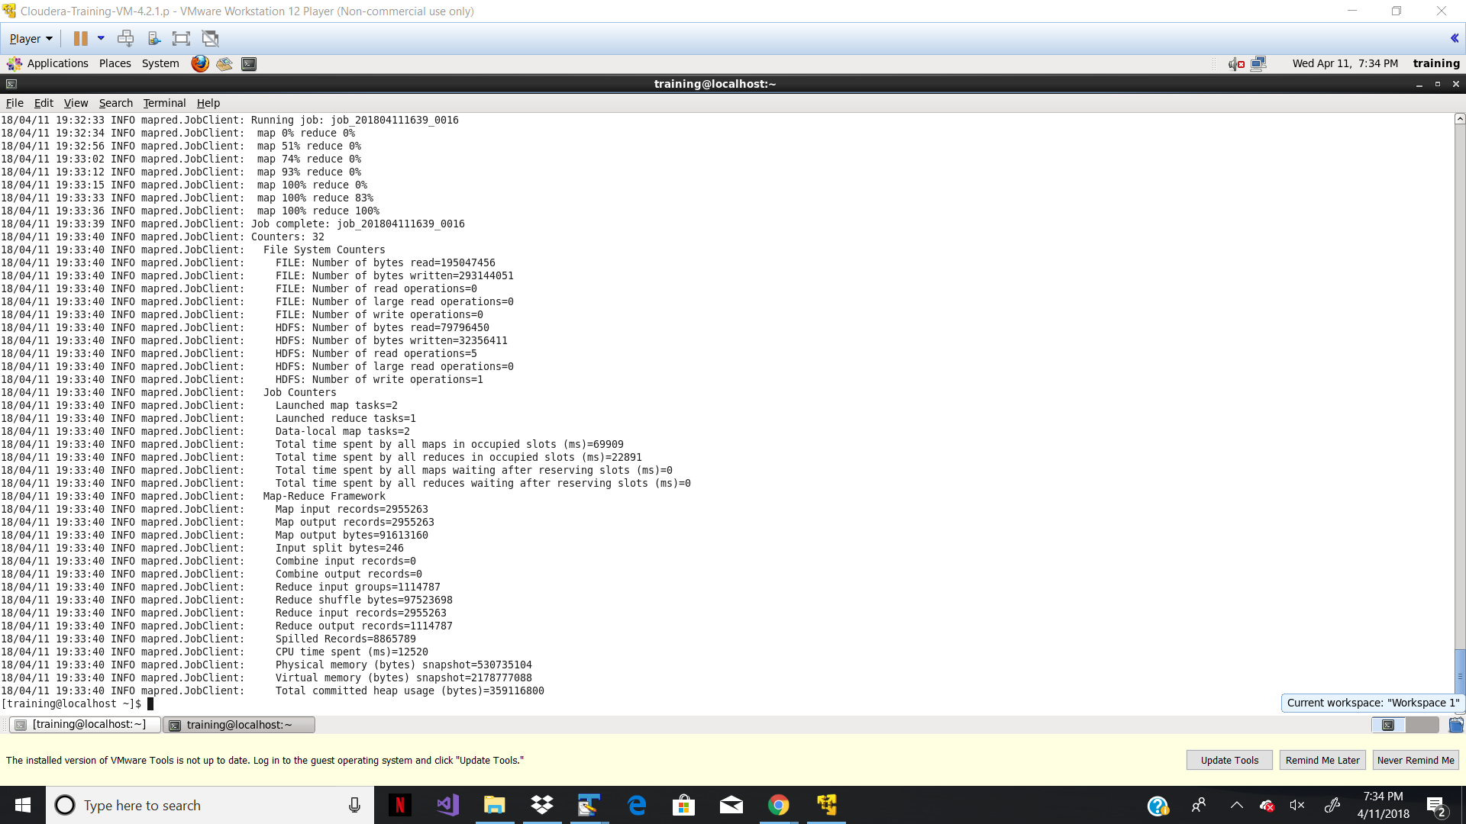

**OUTPUT: -**

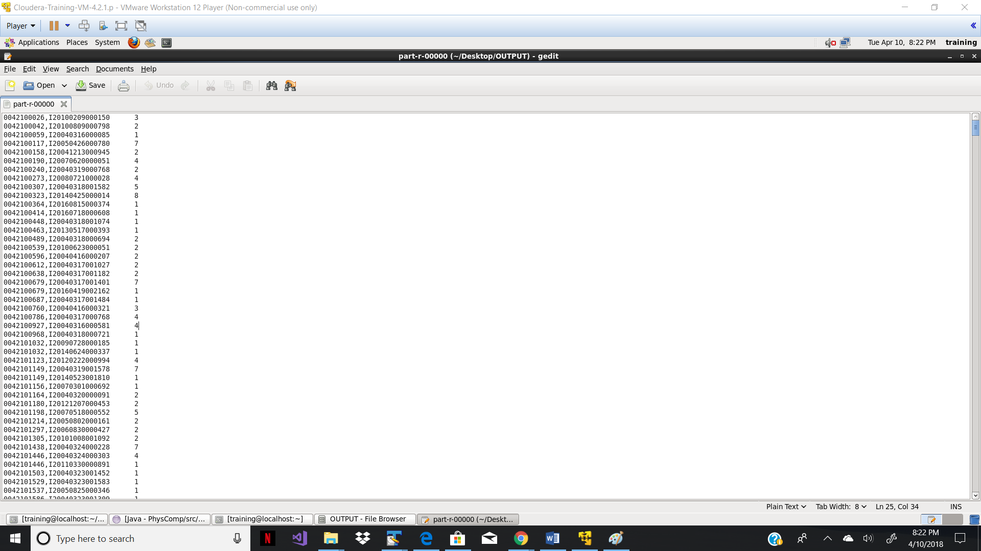

**Hive Programming: -**

1. Folder is created and Physcomp.csv kept on below path: -

Make Directory: -

hadoop fs –mkdir /user/training/PhysComp/hive/PhysComp

Copy File from Local system to Hadoop File system: -

Hadoop fs –put /home/training/Desktop/Sample.csv /user/training/PhysComp/hive/PhysComp/

1. Data Loaded on HIVE tables: -

create table physComp_source (npi int, pac_id int, prof_enrl_id string, l_name string, f_name string, m_name string, sfx string, gender string, credential string, med_schl_nm string, grad_year int, primary_spcl string,secondary_spcl1 string, secondary_spcl2 string, secondary_spcl3 string, secondary_spcl4 string, all_scnd_spcl string, org_legal_name string, grp_prct_pac_id int, no_of_grp_prct_mem string, l1_street_addr string, l2_street_addr string, mrkr_addr_l2 string, city string, state string, zip_code int, phone_number int, hospital_affl_ccn1 string, hospital_affl_lbn_1 string, hospital_affl_ccn_2 string, hospital_affl_lbn_2 string, hospital_affl_ccn_3 string, hospital_affl_lbn_3 string, hospital_affl_ccn_4 string, hospital_affl_lbn_4 string, hospital_affl_ccn_5 string, hospital_affl_lbn_5 string, acpt_medi_asgn string, rep_qlt_msr string, used_elct_hlth_rec string, million_hearts_initiative string) COMMENT 'PHYSCOMP Data' ROW FORMAT DELIMITED FIELDS TERMINATED BY ',' STORED AS TEXTFILE LOCATION '/user/training/PhysComp/hive/PhysComp/Sample.csv';



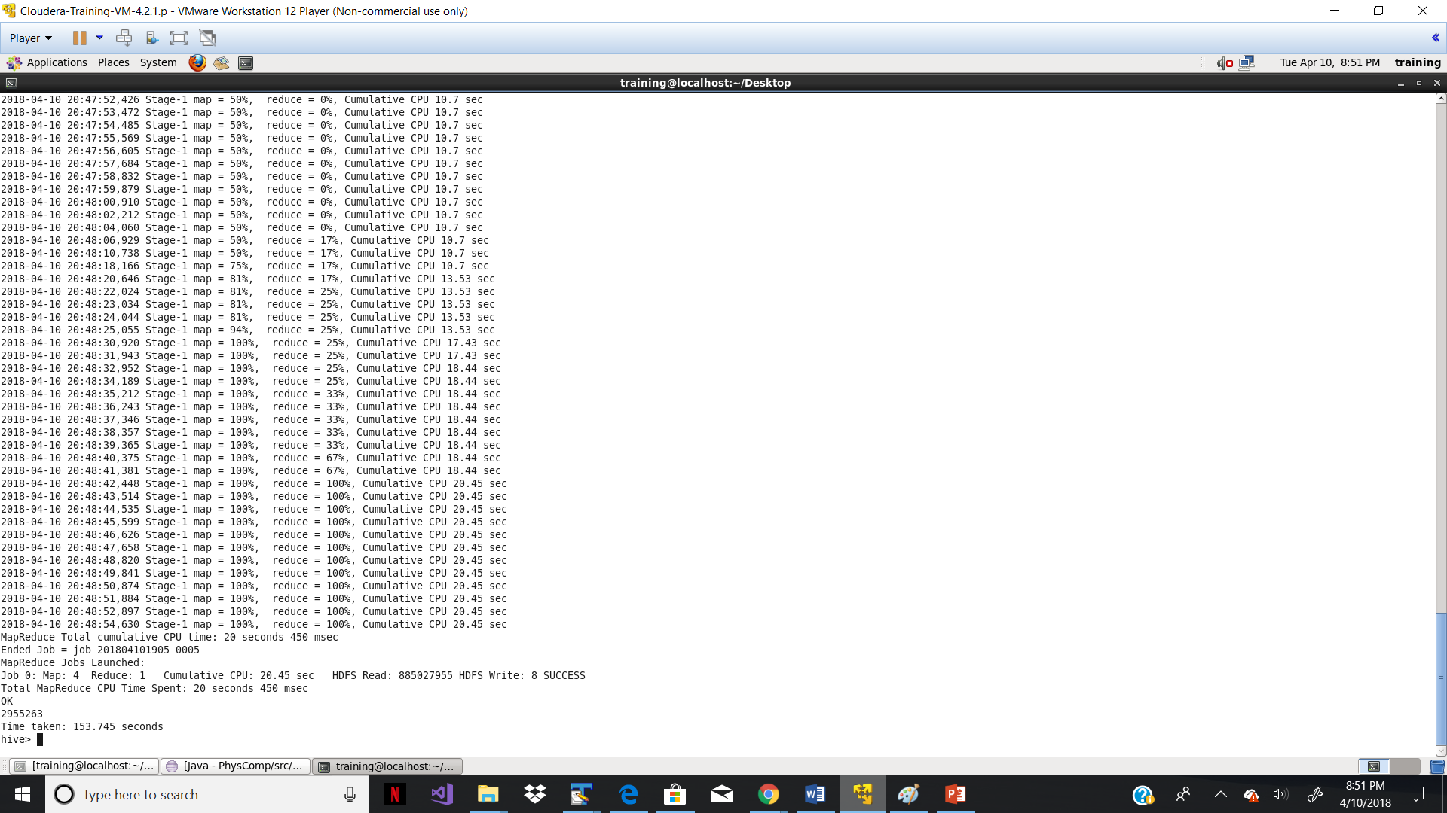

1. Generating Report on basis of Specialization: -

Create a static table only Specialties for data cleansing as so many random values were populated from source dataset: -

create table Specialties as select distinct primary_spcl from Physcomp_source where primary_spcl IN

('ADDICTION MEDICINE','ADVANCED HEART FAILURE AND TRANSPLANT CARDIOLOGY', 'ALLERGY/IMMUNOLOGY', 'ANESTHESIOLOGY', 'ANESTHESIOLOGY ASSISTANT', 'AUDIOLOGIST', 'CARDIAC ELECTROPHYSIOLOGY', 'CARDIAC SURGERY', 'CARDIOVASCULAR DISEASE (CARDIOLOGY)', 'CERTIFIED NURSE MIDWIFE', 'CERTIFIED REGISTERED NURSE ANESTHETIST', 'CHIROPRACTIC', 'CLINICAL NURSE SPECIALIST','CLINICAL PSYCHOLOGIST', 'CLINICAL SOCIAL WORKER', 'COLORECTAL SURGERY (PROCTOLOGY)', 'CRITICAL CARE (INTENSIVISTS)', 'DENTIST', 'DERMATOLOGY', 'DIAGNOSTIC RADIOLOGY', 'EMERGENCY MEDICINE', 'ENDOCRINOLOGY', 'FAMILY PRACTICE', 'GASTROENTEROLOGY',

'GENERAL PRACTICE', 'GENERAL SURGERY', 'GERIATRIC MEDICINE', 'GERIATRIC PSYCHIATRY',

'GYNECOLOGICAL ONCOLOGY', 'HAND SURGERY','HEMATOLOGY','HEMATOLOGY/ONCOLOGY',

'HEMATOPOIETIC CELL TRANSPLANTATION AND CELLULAR TH', 'HOSPICE/PALLIATIVE CARE',

'HOSPITALIST', 'INFECTIOUS DISEASE', 'INTERNAL MEDICINE','INTERVENTIONAL CARDIOLOGY',

'INTERVENTIONAL PAIN MANAGEMENT', 'INTERVENTIONAL RADIOLOGY', 'MASS IMMUNIZATION ROSTER BILLER', 'MAXILLOFACIAL SURGERY', 'MEDICAL ONCOLOGY', 'MEDICAL TOXICOLOGY', 'NEPHROLOGY',

'NEUROLOGY','NEUROPSYCHIATRY','NEUROSURGERY','NUCLEAR MEDICINE','NURSE PRACTITIONER','OBSTETRICS/GYNECOLOGY','OCCUPATIONAL THERAPY','OPHTHALMOLOGY','OPTOMETRY','ORAL SURGERY','ORTHOPEDIC SURGERY','OSTEOPATHIC MANIPULATIVE MEDICINE','OTOLARYNGOLOGY','PAIN MANAGEMENT','PATHOLOGY','PEDIATRIC MEDICINE','PERIPHERAL VASCULAR DISEASE','PHYSICAL MEDICINE AND REHABILITATION','PHYSICAL THERAPY','PHYSICIAN ASSISTANT','PLASTIC AND RECONSTRUCTIVE SURGERY','PODIATRY','PREVENTATIVE MEDICINE','PSYCHIATRY','PULMONARY DISEASE','RADIATION ONCOLOGY','REGISTERED DIETITIAN OR NUTRITION PROFESSIONAL','RHEUMATOLOGY','SLEEP MEDICINE','SPEECH LANGUAGE PATHOLOGIST','SPORTS MEDICINE','SURGICAL ONCOLOGY','THORACIC SURGERY','UROLOGY','VASCULAR SURGERY')

**To get Professionals with same specialties with single specialization: -**

select a.prof_enrl_id, a.primary_spcl,count(*) from physcomp_source a join Specialties b on (a.primary_spcl=b.primary_spcl) group by a.prof_enrl_id,a.primary_spcl having count(*) =1;

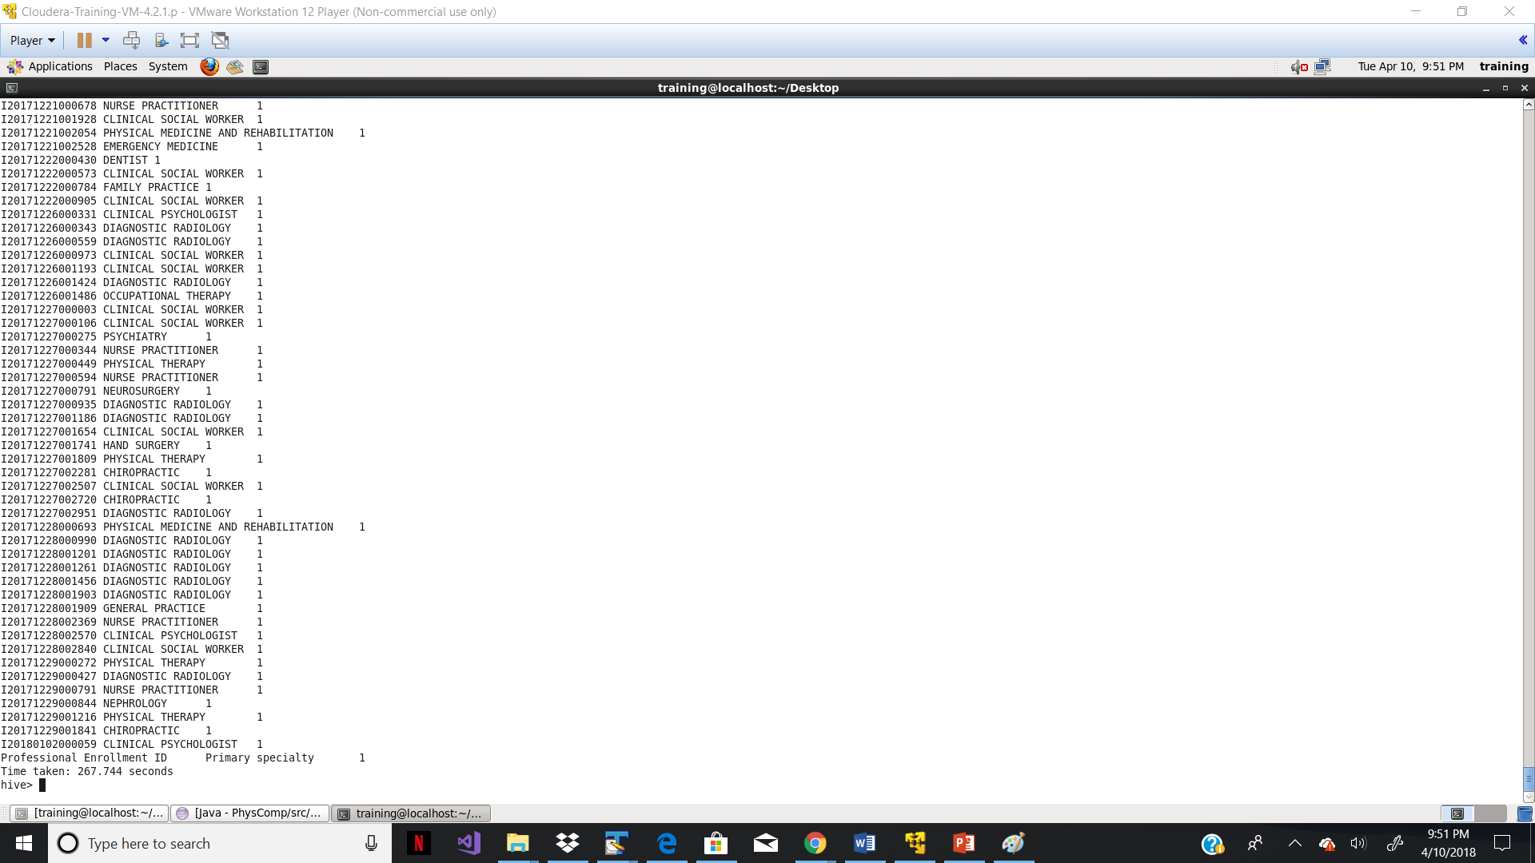

**To get Professionals with same specialties with multiple specialization: -**

select a.prof_enrl_id, a.primary_spcl,count(*) from physcomp_source a join Specialties b on (a.primary_spcl=b.primary_spcl) group by a.prof_enrl_id,a.primary_spcl having count(*) >1;

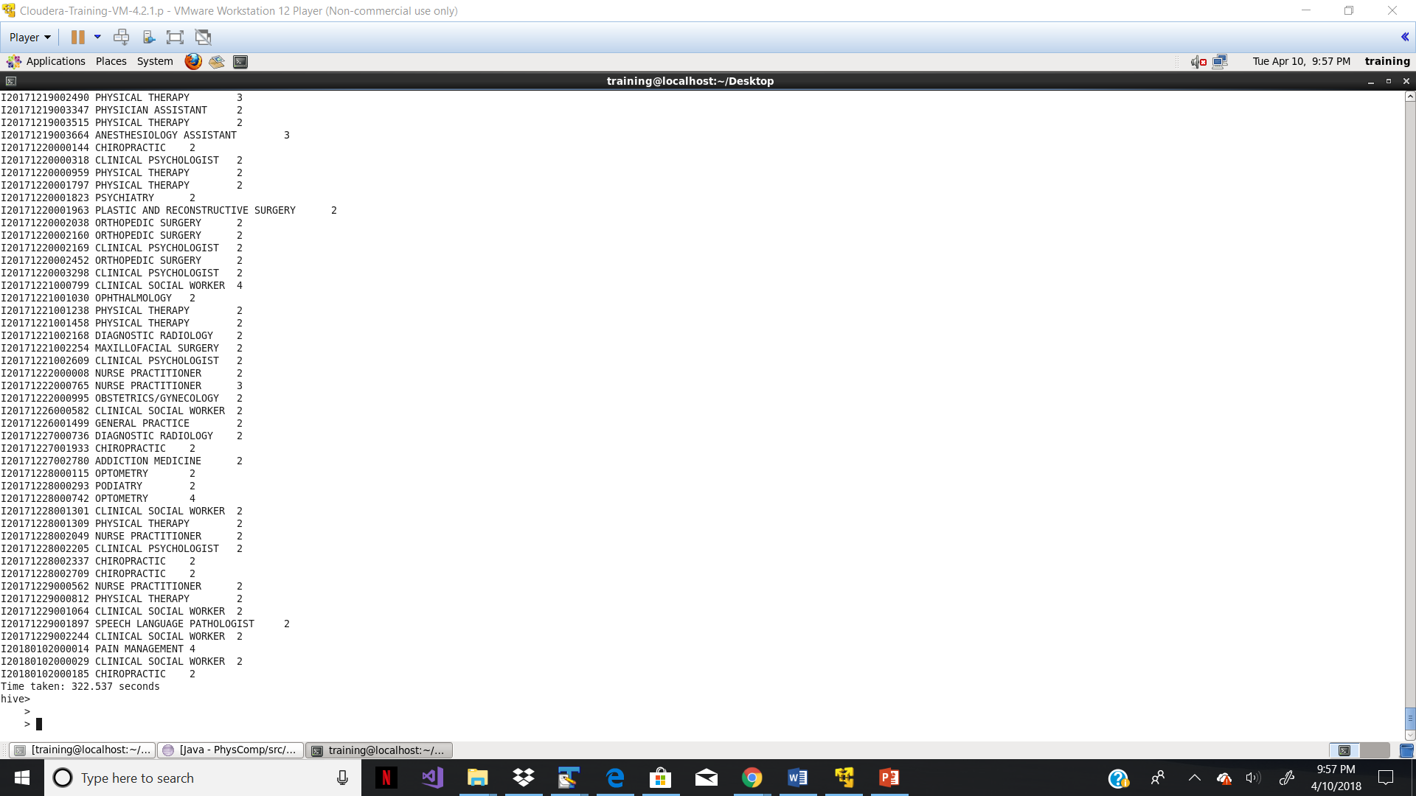

**--> Static Partition: -**

I have use static portioning to store the data on basis of graduation year of physicians.

For that created separate table than source table.

Table Creation Scripts: -

create table physcomp_grad_year(npi int,pac_id int,prof_enrl_id string, l_name string, f_name string, m_name string, sfx string , gender string, credential string, med_schl_nm string )partitioned by (grad_year int);

Insert data on basis of partitions: -

hive> insert into table physcomp_grad_year partition (grad_year=2009) select npi,pac_id,prof_enrl_id,l_name,f_name,m_name,sfx,gender,credential,med_schl_nm,grad_year from physcomp_source where grad_year =2009 ;

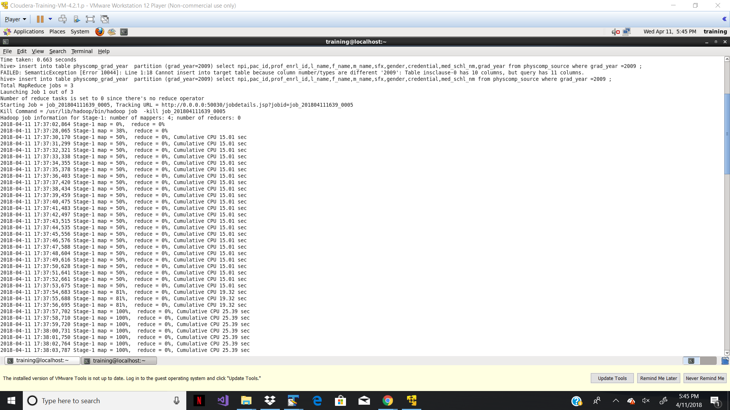

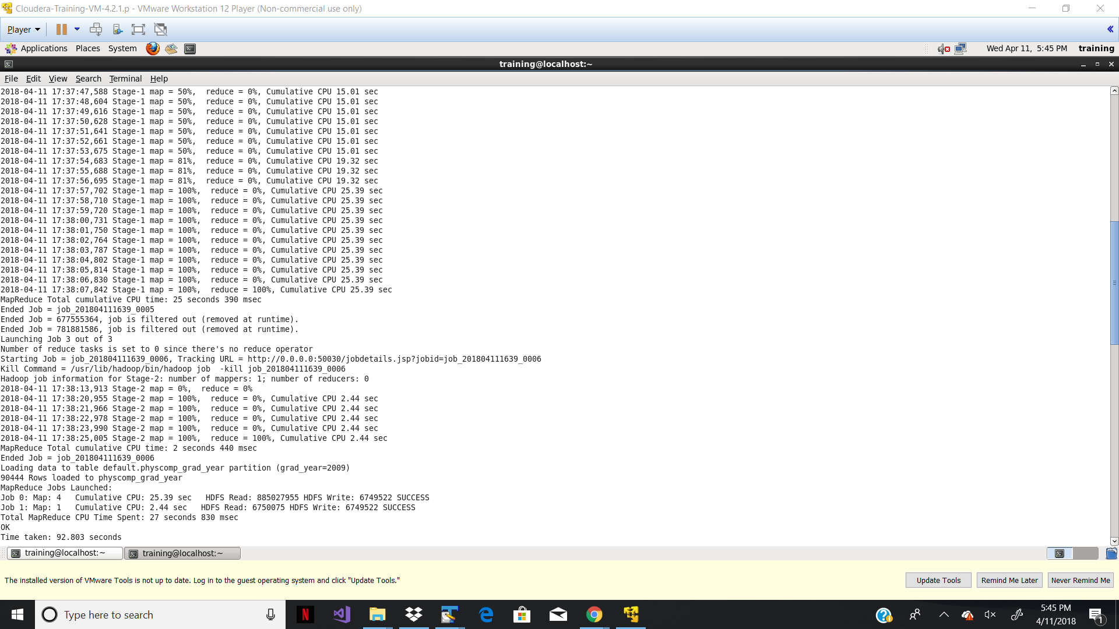

hive> insert into table physcomp_grad_year partition (grad_year=2010) select npi,pac_id,prof_enrl_id,l_name,f_name,m_name,sfx,gender,credential,med_schl_nm,grad_year from physcomp_source where grad_year =2010;

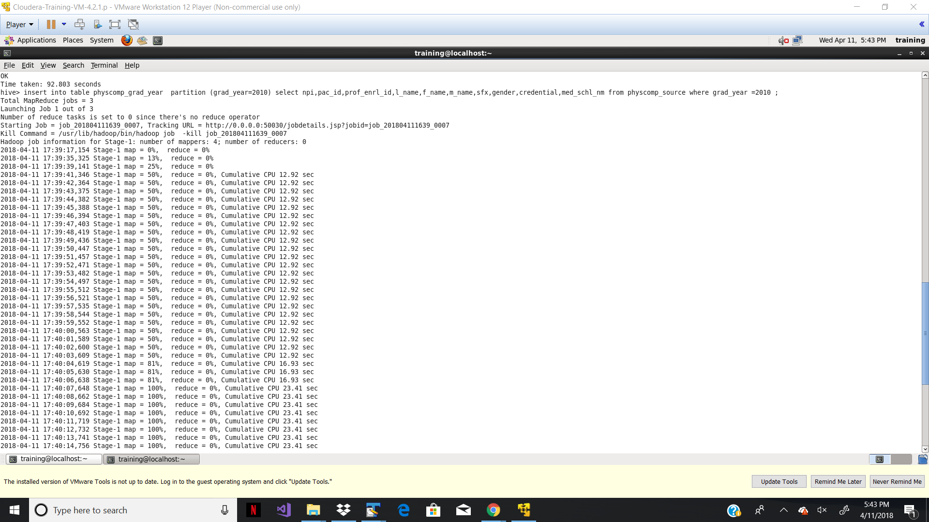

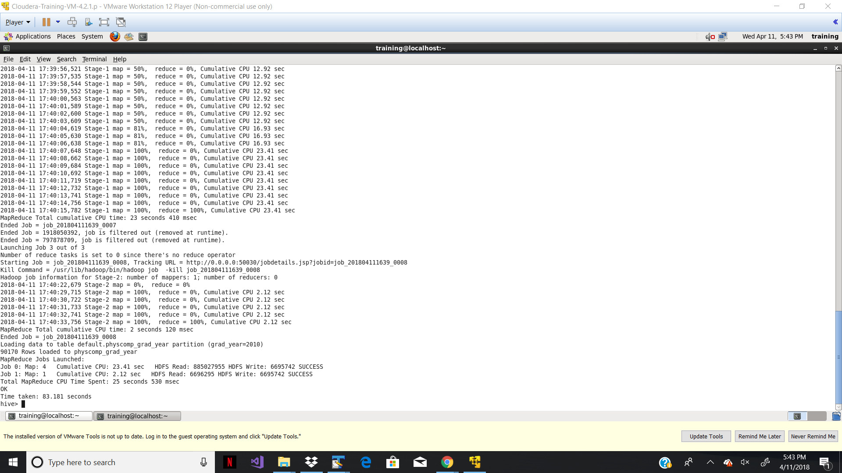

**Data inserted in Physcomp_grad_year tables on basis of partitioning: -**

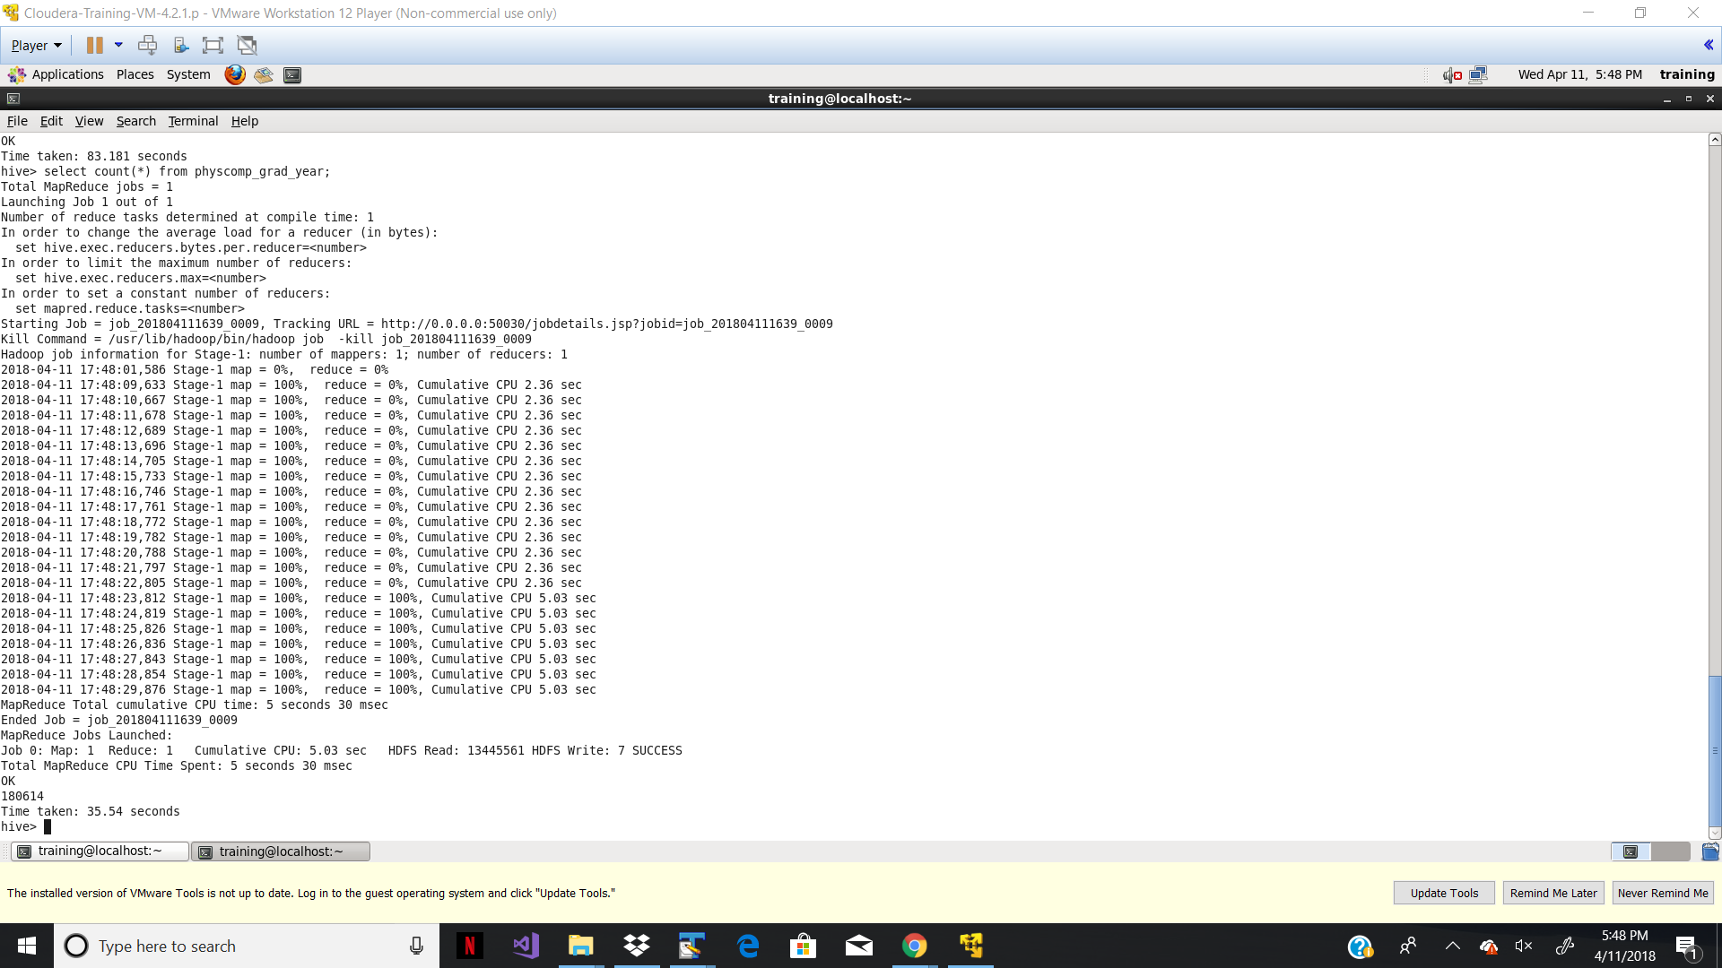

* **-Dynamic Partition: -**

There are couple of data issues from source datasets. While loading data from source dataset, it was unable to load. Hence, I have tried to implement dynamic partition on very few datasets.

For this I have used table which is created in static partition.

**For Dynamic Partition separate table created: -**

hive> create table physcomp_grad_yr(npi int,pac_id int,prof_enrl_id string, l_name string, f_name string, m_name string, sfx string , gender string, credential string, med_schl_nm string ) partitioned by (grad_year int);

**Data Inserted in Physcomp_grad_yr from Physcomp_grad_year-**

insert into table physcomp_grad_yr partition (grad_year) select npi,pac_id,prof_enrl_id,l_name,f_name,m_name,sfx,gender,credential,med_schl_nm,grad_year from physcomp_grad_year where grad_year=2009;

**Output:-**

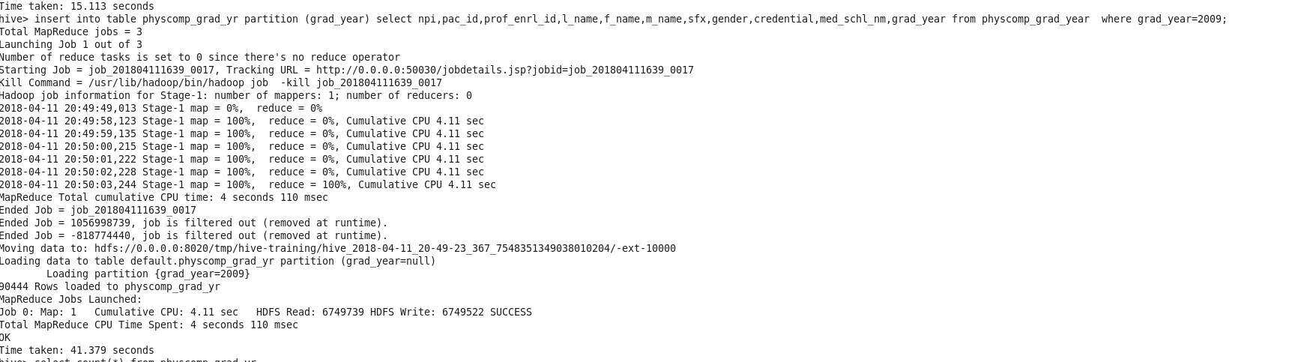

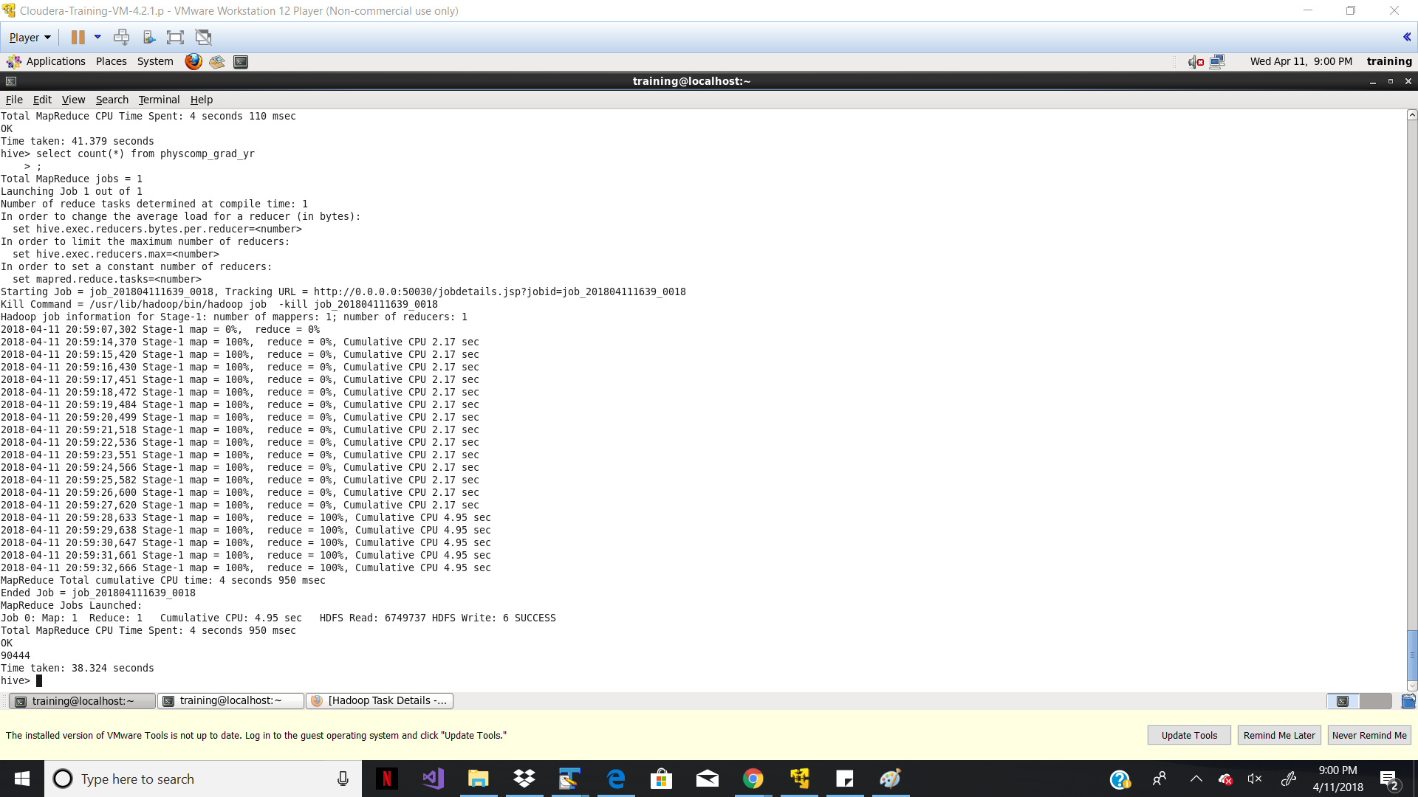

**Pig Relation: -**

To get the number of Female and Male physician, following script can be used: -

A = LOAD '/home/training/Desktop/Sample.csv' USING PigStorage(',');

B = FOREACH A GENERATE $7 AS GENDER;

C = GROUP B BY GENDER;

D = FOREACH C GENERATE COUNT(B.GENDER) AS COUNT;

STORE D INTO '/home/training/pig/OUTPUT4' USING PigStorage();

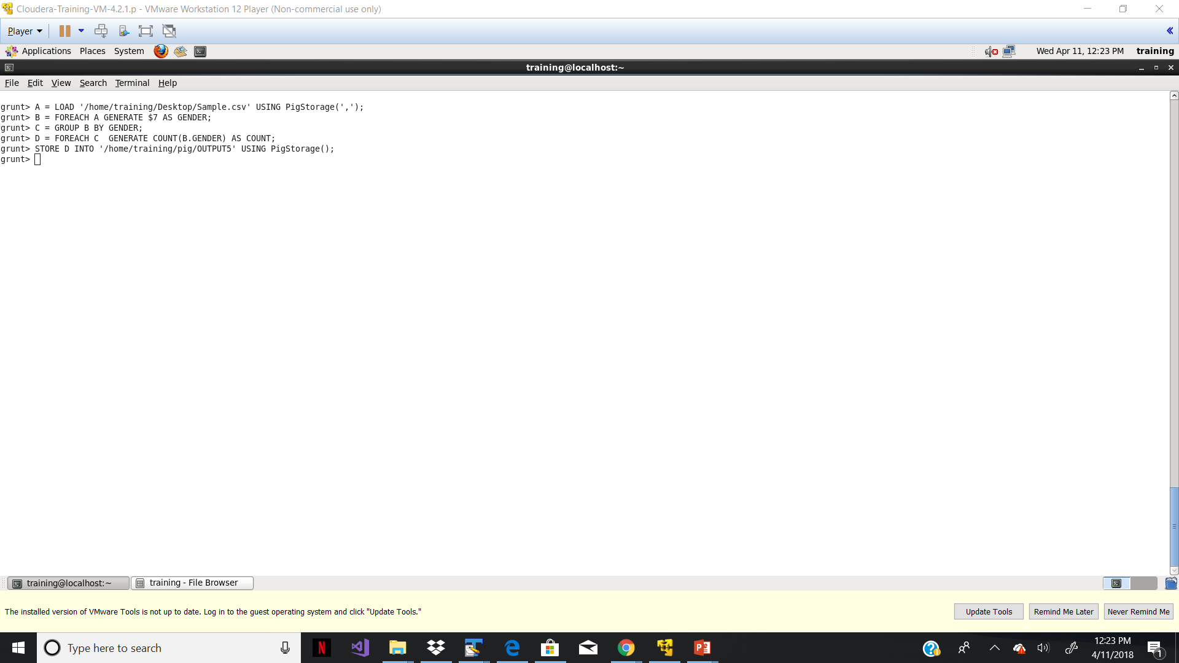

**Output: -**

